Title (Font format: Times New Roman, 20pt; Bold; Centered)
Name Surname^{1,*}, Name Surname², … (Font format: Times New Roman, 12 pt; Centered)
¹Affiliation …(Font format: Times New Roman, 10 pt; Centered)
²Affiliation …
*E-mail (corresponding author): …

ABSTRACT  This study tries to…………… (Font format: Times New Roman, 10 pt; justified; left and right indentation) | Paper type: Research or Review
Received …
Revised …
Accepted …

Keywords:
keywords 1;
keywords 2;
…

- Main section (Font format: Times New Roman, 11 pt; Bold)
  - Subsection (Font format: Times New Roman, 11 pt; Italic)
    - Subsubsection (Font format: Times New Roman, 10 pt; Bold)
Use only symbols and characters available in Times New Roman or Symbol font, 11pt; paragraph format: justified alignment, left and right indent 0 pt, space before and after 0 pt, first paragraph is without any indent 0 cm, but the next paragraphs must be indented 0.5 cm. Line spacing is set to 1.5 lines. Add a space after the last paragraph of a section or subsection.
Equation Editor or MathType Editor can be used to typeset the formulas, for instance
$c_{j}=∂×a_{j} ∀j∈J.$ | (1)
Refer to equations in the text as Eq. (1), or Eqs. (1) and (2).

Caption of the tables and figures must be given at the top and bottom, respectively (Font format: Times New Roman, 10 pt; centered). For example,
Table 1. Write the caption here.
Supported by | Goals and Strategies | Actions
Figure1 | Making transportation planning | Using the developed MOP model
Figure 2 | Profit Maximization | Market development
Figure 3 | Avoiding the growth of unmet demand | Expanding the market based on supply chain capabilities

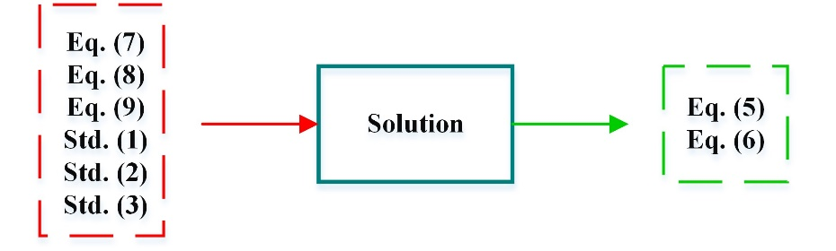
Fig. 1. Write the caption here.
All the figures/tables must be explicitly referenced in the text.
Appendix A. (Font format: Times New Roman, 12 pt; Centered)
Acknowledgement: This work is supported by … (Font format: Times New Roman, 11 pt; Italic).
References
Use APA (American Psychological Association) for in-text and reference list citations. For the in-text citation, the surname of both authors is stated with either ‘and’ or an ampersand between. For example, Mitchell and Smith (2017) state… Or …(Mitchell & Smith, 2017). For the reference list, you can see the following examples:
Mitchell, J.A. (2017). Why is it so important. Mendeley Journal, 67(2), 81-95.
Tirkolaee, E. B., Goli, A., & Weber, G. W. (2020). Fuzzy mathematical programming and self-adaptive artificial fish swarm algorithm for just-in-time energy-aware flow shop scheduling problem with outsourcing option. IEEE Transactions on Fuzzy Systems, 28(11), 2772-2783.

